





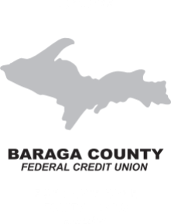



***It Pays to Belong . . .***

***. . . Join Us Today!***



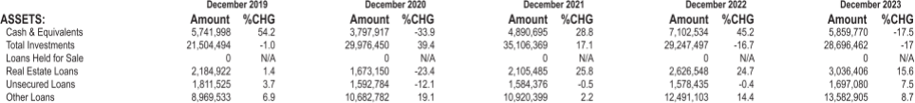





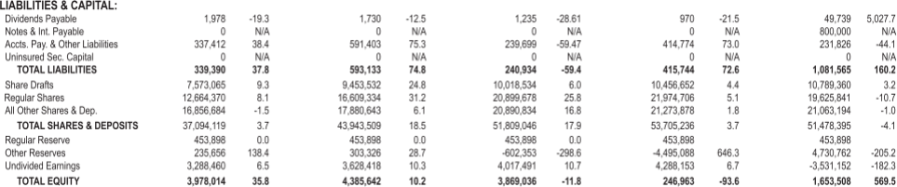



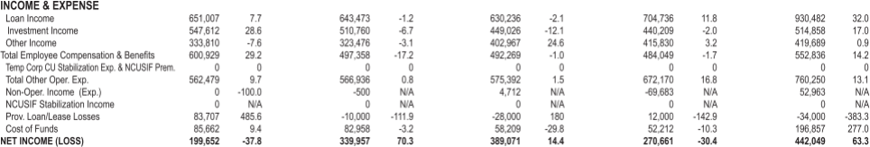





BARAGA COUNTY FEDERAL CREDIT UNION TREASURER’S REPORT FOR 2023

1. In 2023, our C.U. Assets decreased .27% to a total of $54,211,358. Within these Assets, Net Loans increased by 10.01% to a total of $18,226,785.51 (=33.62% of Assets) and Investments decreased by 2% to $28,696,462 (=52.93% of Assets).
2. In 2023, our C.U. Liabilities & Equity also decreased .27% to $54,211,358. Savings decreased 4% to   
   $51,478,398 (=94.96% of Liabilities & Equity) and Equity (Reserves) increased 9.33% to $5,184,660   
   (=1.3% of Liabilities & Equity). At 12/31/2023, we continued to record our Available-for-Sale (AFS) Investments at market value, which resulted in recording an unrealized loss of $3,531,152 on AFS, in the Equity section.
3. In 2023, our C.U. earned $1,917,992 in income (49% from loan interest, 27% from investment   
   interest & 25% from misc. income & fees). Our C.U. disbursed a total of $1,475,943 in expenses & dividends (13% for dividends, 37% for salaries & benefits and 50% for other operating expenses). Our overall expenses increased 20.94% in 2023. Net Income for 2023 was $442,049, which was an increase of $171,388 or 63.32%, from Net Income in 2022.
4. In 2023, total C.U. Members decreased .04% (PY=+1.30%) to a total of 4,504 members as of December 31, 2023.
5. Ratios:   
   Net Worth Ratio Loans to Assets Delinquent Loans Net Charge-offs

OURS

=9.56 (PY=8.72)

=33.79(PY=30.71)

=0.02 (PY=0.10)

=-.15 (PY=0.07)

PEER GROUP   
=11.10(PY=12.65)   
=56.81(PY=53.61)   
=0.84 (PY=.74)   
=0.37(PY=0.25)